MODEL WHISTLEBLOWING PROCEDURE FOR OXFORDSHIRE SCHOOLS
Introduction
1. All schools and academy trusts are required to have appropriate procedures in place for handling whistleblowing and for ensuring school staff know who they can contact if they wish to raise a concern.
2. This document explains the types of concerns that can be raised under this procedure, the legal protection for whistleblowers and how whistleblowing concerns will be handled.
3. This procedure should be followed for any whistleblowing matters raised by employees of the school, supply staff and agency workers.
4. The term 'head teacher' has been used throughout this procedure, however depending on the size and structure of the school the head teacher's role in the procedure may be delegated to other members of the senior leadership team, school business managers or line managers as appropriate. Where the head teacher is subject to these procedures, it will be managed by the Chair of the governing body.
Policy Statement
5. The school is committed to the highest possible standards of:
- openness and inclusiveness
- accountability and
- integrity
Aim of procedure
- To encourage those working in the school to report suspected wrongdoing promptly, in the knowledge that it will be taken seriously.
- To provide guidance on how to raise concerns.
- To reassure staff that they are able to raise genuine concerns made in the public interest without fear of reprisals, even if they turn out to be mistaken.
What is Whistleblowing?
6. Whistleblowing is when a worker reports certain types of wrongdoing or misconduct within an organisation.
7. The wrongdoing disclosed must be in the public interest. This means it must affect others, e.g. pupils, general public.
8. The wrongdoing must relate to or show one of the following:
- a criminal offence
- a failure to comply with a legal obligation
- a possible miscarriage of justice
- a Health & Safety risk
- damaging the environment
- misuse of public money
- corruption or unethical conduct
- abuse of pupils, students or other users
- deliberate concealment of any of these matters
- any other substantial and relevant concern.
9. The concern could be about something that happened in the past, is currently happening or likely to happen in the future.
10. Concerns or complaints that employees wish to raise formally, about their own employment, should normally be raised using the school's Grievance Procedure, unless the employee believes the concern is in the public interest. This includes for example, concerns related to working conditions, working relations, employment rights or bullying or harassment.
Legal protection for whistleblowers
11. Whistleblowers are protected by law from being treated unfairly or losing their jobs because they 'blow the whistle'.
12. Whistleblowers must hold a reasonable belief that the concern they are raising is in the public interest.
13. The school’s governing body will provide all reasonable protection for those who raise concerns made in the public interest.
14. The school's governing body will be responsible for ensuring that appropriate personal support is offered both to a worker raising a concern and to any worker against whom allegations have been made under this procedure.
15. Although an employee has certain legal obligations of confidentiality to the school, in a limited set of circumstances, whistleblowing may override these obligations. This guidance sets out the circumstances under which these disclosures may lawfully be made.
Procedure for raising a whistleblowing concern
Whistleblowing anonymously or confidentially
16. Concerns can be raised anonymously, but the school or person receiving the allegation may not be able to take it further if they haven’t been provided with all the information they need.
17. Whistleblowers can give their name but request confidentiality and in these circumstances, every effort will be made to protect their identity.
18. All disclosures made under this procedure will be treated sensitively, consistently and fairly.
Step 1- Deciding who to report the concern to
19. Concerns can be raised verbally or in writing.
20. You can raise your concern with your line manager. Alternatively, you can raise the matter with the head teacher or the Chair of Governors.
21. If you wish to report the matter to someone outside of the school you can contact the Director of Children, Education and Families, Oxfordshire County Council or any of the other local authority officers listed in Annex 1 or one of the external bodies/organisations listed in Annex 2.
22. Reporting concerns to the media, in most cases will lead to the loss of your whistleblowing law rights.
23. Although you are not expected to prove beyond doubt the truth of your concerns, you will need to demonstrate that you have sufficient evidence or other reasonable grounds to raise them.
24. You may wish to obtain advice from a trade union representative, the Citizen's Advice Bureau or Public Concern at Work on 020 7404 6609 and www.pcaw.co.uk.
25. You can be accompanied by a trade union representative or colleague to any meetings that are required.
Step 2
26. The person with whom you have raised your concern, will decide what action is needed. They may ask you to provide further information. They will write to you within 10 days to let you know how your concern will be dealt with.
27. The information you can expect to receive is:
- an indication of how the concern will be dealt with
- an estimate of how long it will take to provide a final response
- whether any initial enquiries have been made
- whether further investigations will take place, and if not why not
- information about support available for you.

28. The person with whom you have raised your concern will at the same time notify the schools’ HR Adviser that a whistleblowing allegation has been made.
29. Advice on dealing with concerns is available from the school's HR Adviser, legal or financial adviser.
Step 3
30. Initial enquiries will be made to decide whether an investigation is appropriate.
31. An investigation may be carried out, depending on the nature of the allegations and the evidence/information presented. Full details of the investigation may be withheld from you to protect the confidentiality of other people.
32. Information will need to be passed on to those with a legitimate need to have this information and it may be necessary for you to provide a written statement and act as a witness in any subsequent disciplinary proceedings or enquiry. This will be discussed with you first.
33. Where an investigation is necessary, it may take the form of one or more of the following:
- an internal investigation by the head teacher or a governor, which may, for example, take the form of a disciplinary investigation
- an investigation by the Internal Audit Service
- a referral to the Police
- the setting up of an external independent inquiry.
Step 4
34. You will be informed of the outcome of any investigation, in writing, and/or of any action taken, subject to the constraints of confidentiality and the law.
35. If you do not feel your concern has been addressed adequately you may raise it with an independent body such as one of the following as appropriate:
- your trade union
- the Citizens Advice Bureau
- a relevant professional body or regulatory organisation
- a relevant voluntary organisation
- the Police
- the Local Government Ombudsman
- Equality and Human Rights Commission
(See Annex 2 for further details).
36. If there is an issue of an exceptionally serious nature which you believe to be substantially true, then you may disclose the issue to someone other than those listed in paragraph 21. In determining whether it is reasonable for you to have made a disclosure the identity of the person to whom the disclosure is made will be taken into account. Disclosures to anyone outside of the recognised bodies listed in paragraphs 35 and Annex 1 and 2 may not be protected disclosures under the Act.
37. You have a duty to the school not to disclose confidential information. This does not prevent you from seeking independent advice at any stage or from discussing the issue with the charity Public Concern at Work on 020 7404 6609 and www.pcaw.co.uk in accordance with the provisions of the Public Interest Disclosure Act 1998.
Review and Reporting of the Procedure
38. For maintained and voluntary controlled schools Oxfordshire County Council’s Head of Paid Service, and the Council's Monitoring Officer, have overall responsibility for this procedure.
39. For voluntary aided and foundation schools the responsibility will lie with the Governing Body, and for academies with the Academy Trust.
40. This procedure has been reviewed with reference to equalities, human rights and discrimination legislation. Confidential monitoring of the procedures is undertaken in order to gather data to help establish whether the procedure is operated in a fair and consistent manner. In undertaking monitoring the school will not identify individuals.
41. This procedure will be regularly reviewed by the Monitoring Officer to ensure that it continues to remain compliant and meets the needs of Schools and those working in schools.
Responsible Officer: Monitor Officer
July 2020

Annex 1 - Contact list for Oxfordshire County Council
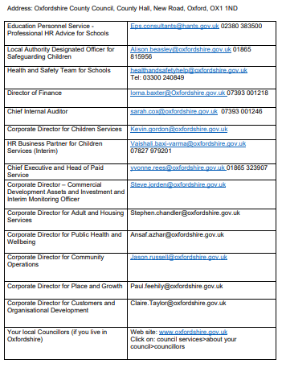

Annexe 2 - External bodies and organisations
You can blow the whistle to an external organisation rather than your employer. There is a list of prescribed people or bodies that you can go to. Choose the correct one for your issue. A full list can be found online at Gov.Uk: https://www.gov.uk/government/publications/blowing-the-whistle-list-of-prescribedpeople-and-bodies--2/whistleblowing-list-of-prescribed-people-and-bodies
Some of the bodies that may be relevant for school staff are:
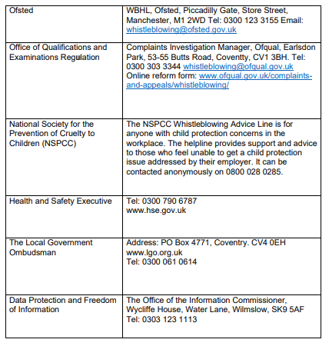
Approved by: | FGB | Date: 29.09.2025
Last reviewed on: | 22.09.2025
Next review due by: | 2.09.2026

